How to Create User-Defined Functions in Oracle
Example to Understand User-Defined Function in Oracle:
Create a function to return the salary for an employee. We need one parameter (in) number (employee_id). The return value should also be a number because it is salary. Please execute the below SQL Statement to create the function in the Oracle database.
create or replace function get_sal
(p_emp_id number)
return number
is
v_sal number;
begin
select salary into v_sal
from employees
where employee_id=p_emp_id;
return v_sal;
end;
This is the statement for create function. We have created the function name with get_sal. This function takes an in parameter p_emp_id where the datatype is a number. This function also returns a number which is v_sal and the datatype is a number.
The PL/SQL block here indicates that we are giving the employee_id using the in-parameter p_emp_id and the PL/SQL block retrieves the salary of the given employee_id in the table employees. The salary will be stored in the parameter v_sal. The parameter v_sal will be returned to the function. The parameter will display the output to the user i.e. the salary using the v_sal parameter. Let’s go ahead and compile this function.
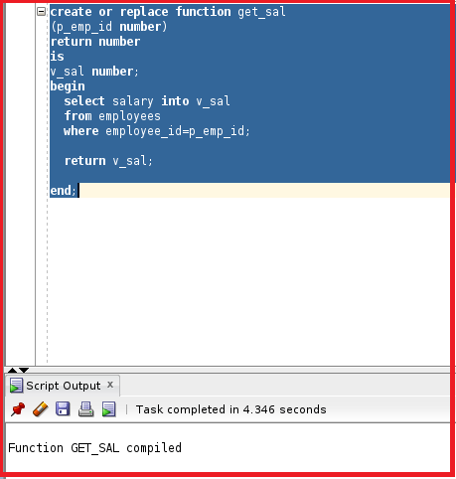
The function is now compiled. Let’s go ahead and invoke the function. There are several methods to invoke a function.
Methods to Invoke a Function in Oracle:
Let us understand the different methods available in Oracle to Invoke User Defined Functions.
Method 1: Invoke a part of the Expression.
declare
v_sal number;
begin
v_sal:=get_sal(1011);
dbms_output.put_line (v_sal);
end;
We can invoke a function as a part of the expression. We have declared a variable v_sal with the datatype number. We have assigned that variable to the function get_sal. The get_sal will return a value and the value will be stored in the variable v_sal.
We have given the in parameter as 100. So, the 100 will be assigned to p_emp_id as it is employee_id. The PL/SQL block will select the table employees with the employee_id as 100 and will return a value of salary to the variable v_sal. The v_sal will return a value to the function. The returned value will be saved in the v_sal variable which is invoked as a part of the expression. We can use dbms_output to display the v_sal parameter. Let’s go ahead and execute the PL/SQL block.
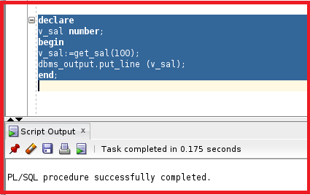
So, the PL/SQL block is successfully compiled. Let’s check DBMS_OUTPUT as we have mentioned the DBMS_OUTPUT.
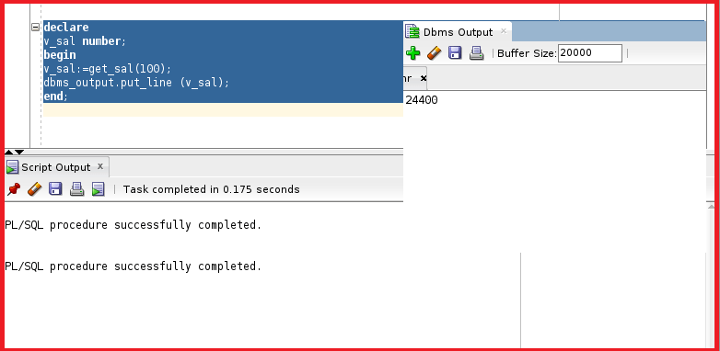
We can see the DBMS Output is 24200 which is the salary of emp_id 100.
Method 2: Invoke Function as a Parameter Value.
Another way to use the function as a parameter value. In the DBMS_OUTPUT.PUT_LINE we can invoke the function and the value returned by the function will be displayed in the DBMS_OUTPUT.
begin
dbms_output.put_line (get_sal(100));
end;
Let’s try to execute this.
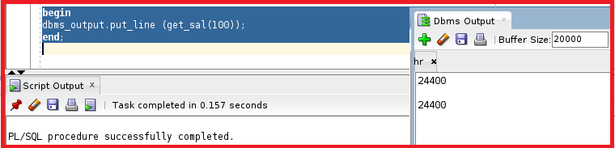
We can see this displayed the same salary as the previous method.
Method 3: Invoke Function in the Execute Statement.
We can also execute because DBMS_OUTPUT is a package and PUT_LINE is the procedure. We will understand more about the package in the upcoming articles.
execute dbms_output.put_line(get_sal(100));
Let’s try to execute this.
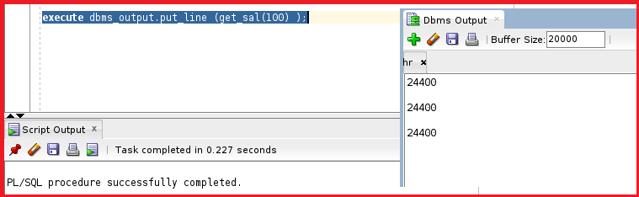
We got the same result as the previous methods.
Method 4: Invoke Function By Defining a Bind Variable.
Let’s define a bind variable b_salary and assign the variable to the output of the function. So, the value returned by the function will be assigned to the bind variable and we can use the bind variable to print the value.
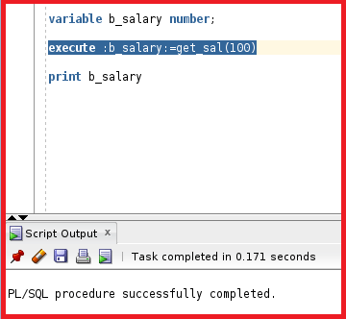
So, we have created the bind variable b_salary and executed calling the function get_sal where the out value of the function is assigned to the variable b_salary. Now, let’s try to print the variable b_salary.
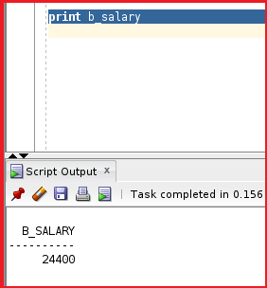
So, we got the same salary as the previous methods.
Method 5: Invoke Function as a part of the Select Statement
We can invoke a function in the select statement.
select get_sal(100) from dual;
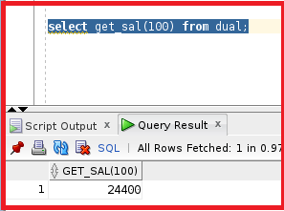
So, we can able to call the function in the select statement as well. Let’s try another method.
Select employee_id, first_name, get_sal(employee_id) from employees Where department_id=20;
So, we fetching the salary of all employees whose department_id is 20. Let’s execute this statement and see the output.
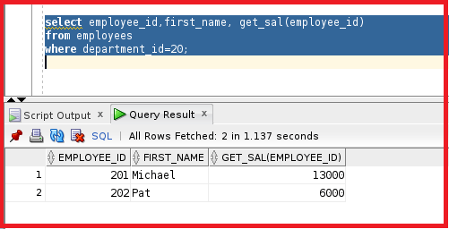
So, this method is not good practice because the salary column is already present inside the table employees. By using the function in this select statement the function will be executed for each row. It means the function will take emp_id as 1 to 200. The function will be executed 200 times which is not a good sign.
How to find a function in user_objects?
The function will be in a table called user_objects. We can get the details of the function by using the table user_objects.
select * from user_objects where object_name=’GET_SAL’;
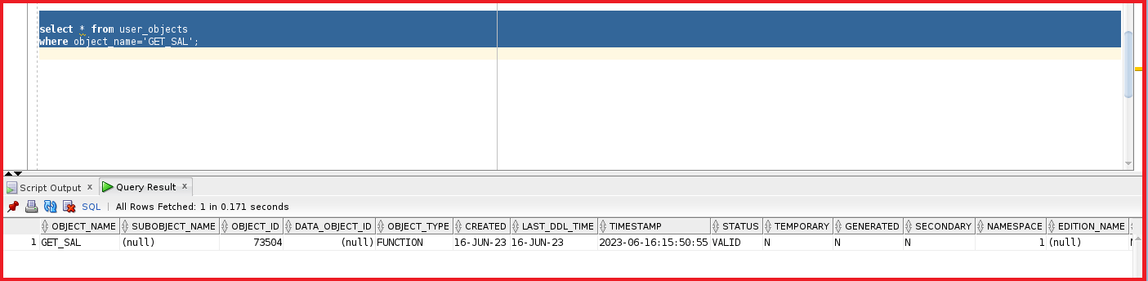
We can see the object_name as GET_SAL and the object_type is a function and the status is Valid. We can also SQL code of the function using the view user_Source.
select line, text from user_source where name=’GET_SAL’;
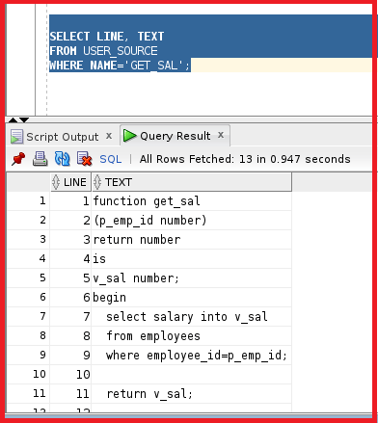
We can see the SQL code used to create the function get_sal.
No_data_found in Oracle:
Let’s see the code of the function that we have created.
create or replace function get_sal
(p_emp_id number)
return number
is
v_sal number;
begin
select salary into v_sal
from employees
where employee_id=p_emp_id;
return v_sal;
end;
The code for this function doesn’t contain an exception section. Let’s try to execute this function using method 2 and see the output once.
begin
dbms_output.put_line (get_sal(100));
end;
We can see the result. Now, let’s do the same example and give the employee_id as out of scope. Let’s try to give 9999. Actually, we don’t have an employee with employee_id 9999. Let’s try to execute this statement and see if we get any exceptions.
begin
dbms_output.put_line (get_sal(100));
end;
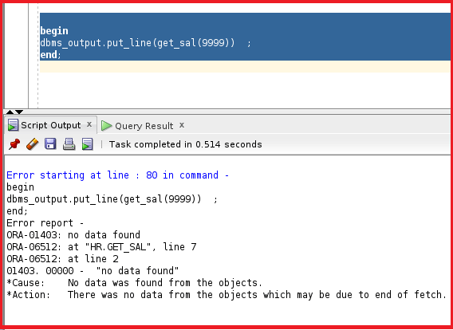
So, we can the output as no data found. When we try to execute this 9999 from a select statement, we may get null. Let’s try to execute that as well.
Select get_sal(9999) from dual;
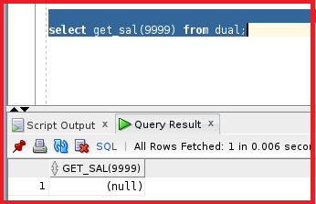
We can see null. So, if the function does not contain an exception we will get no_data_found. Let’s try to create the function with an exception.
create or replace function get_sal
(p_emp_id number)
return number
is
v_sal number;
begin
select salary into v_sal
from employees
where employee_id=p_emp_id;
return v_sal;
exception
when no_data_found then
return -1;
end;
In the exception section, we have mentioned that if no_data_found then we can return it with -1. The return in exception should be of the same data type as the return in the function. Let’s try to compile the function.
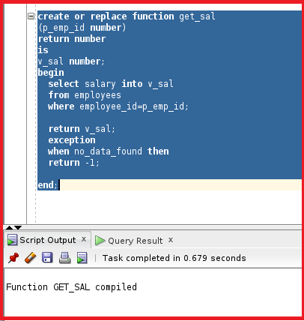
So, the function is now compiled. Let’s now try to check the function using the 9999 employee_id
select get_Sal(9999) from dual;
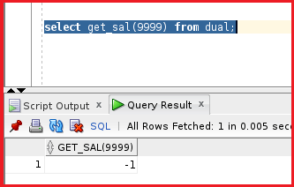

Advantages of User-Defined Functions in Oracle
We have already learned that we can use user-defined functions in SQL statements. But now let’s understand the advantages of using the user Defined functions.
Advantages of Functions in Oracle:
- Can extend SQL where activities are too compiled, too awkward, or unavailable with SQL. Sometimes we have very complex SQL codes that normally are unable to perform. So, we use the user-defined function in that situation.
- Can Increase efficiency when used in the WHERE clause to filter data, as opposed to filtering the data in the application.
- Can manipulate data values. We can use the user-defined functions in insert or update.
Calling User-Defined Functions in SQL Statements:
User-defined functions act like built-in single-row functions and can be used in:
- We can deal with the user-defined functions just like built-in functions like upper, lower, init char, in string, and substring.
- The SELECT list or clause of a query.
- Conditional expression of the WHERE AND HAVING clauses.
- The CONNECT BY, START WITH, ORDER BY, AND GROUP BY clauses of a query. This is the feature for Oracle queries.
- The VALUES clause of the INSERT statement.
- The SET clause of the UPDATE statement.
Now, let’s do some exercises about the user-defined functions. Let’s go ahead and create a function to calculate the tax on the salary. If the salary is greater than 5000 then the tax is 10 % or else the tax is 15%.
create or replace function get_sal_tax
(p_sal number)
return number
is
begin
if p_sal<5000 then
return p_sal* (10/100);
else
return p_sal* (15/100);
end if;
end;
We have created a function with the name “get_sal_tax” where we are taking p_sal as IN parameter which also returns a number. The main logic of the function is if the p_sal is less than 5000 then return 10% of the p_sal value or else return 15% of the p_sal value. We are using the percentage as p_sal multiplying with 10 or 15 and dividing by 100 which finally gives the percentage of the p_sal variable. Let’s go ahead and compile this function.
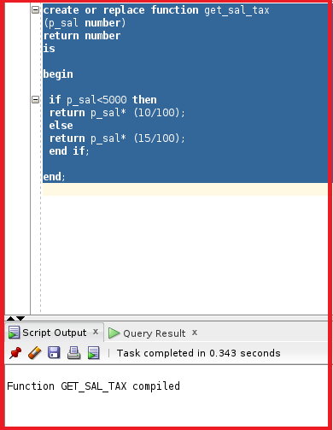
So, the function GET_SAL_TAX is now compiled. Let’s try to test the function by checking the percentage of each employee in the employees table.
Select employee_id, first_name, salary, get_sal_tax(salary) from employees;
Here we are trying to call the function in the select statement and passing salary as the IN parameter to the function GET_SAL_TAX. Now, let’s try to run this statement and see the percentage.
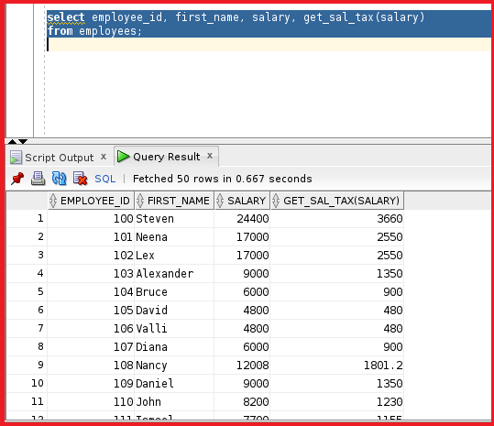
We can see the GET_SAL_TAX column in the output. From the output, we can see the employee Steven has a salary of 24400 which is more than 5000 so his percentage is 15%. So, Steven’s tax as per our function calculation is 3660. So, as per the function, the salary 24400 is sent to the function as the IN parameter and then the salary is converted into tax and returned by the function.
We can use the user-defined functions in both SQL statements and select statements. I will use the same example and use the naming notation.
Select employee_id, first_name, salary, get_sal_tax(p_sal=>salary) from employees;
We are calling the function in the select statement and passing the parameter p_sal which takes salary as the value. Let’s try to execute this statement.
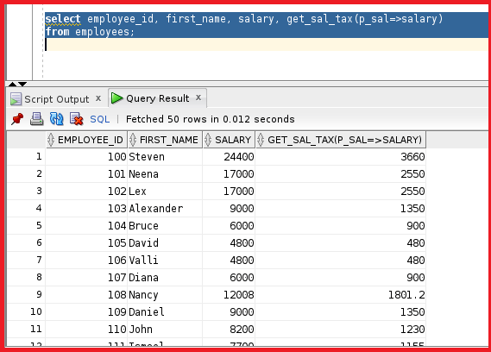
As we can see the output is the same as the previous result. Let’s try something different.
Select employee_id, first_name, salary, get_sal_tax(salary) from employees where get_sal_tax(salary)>2000 order by get_sal_tax(salary);
So, we are filtering the tax which is more than 2000, and ordering by function.
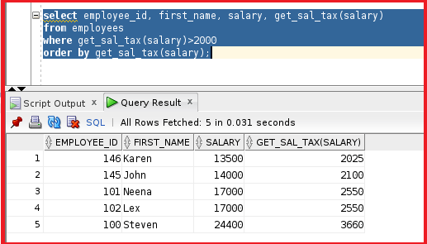
So, we can see only 5 employees whose tax in the salary is greater than 2000. This is how we perform user-defined functions in our Realtime based scenarios.

Restrictions When Calling Functions in Oracle
Until now we understood how to use the user-defined functions in select statements in select clauses and in the where conditions. Now, let’s try to understand restrictions when calling functions from SQL expressions.
- The functions must be stored in the database. We can even use the functions without storing in the database. We will learn that when we start learning about packages.
- The user-defined functions accept only IN parameters with valid SQL data types, not PL/SQL-specific types (Record, table, Boolean). So, in order to use the user-defined functions it should only contain only IN parameter.
- Return a valid SQL data type, not the PL/SQL – specific data types.
- When calling functions in SQL statements the parameters must be specified with positional notation but this is before the 11g version of the Oracle database. But now we can call the function with the naming convention.
- You must own the function or have the execute privilege.
- Cannot be used in check constraints. (Create table/ alter table).
- Cannot be used as a default value for a column.
Controlling side effects when calling functions from SQL expressions.
Functions called from:
- A SELECT statement cannot contain DML statements. In order to use the function in the select statement the function does not contain the DML Statements.
- An update or delete statement on a table cannot query or contain DML on the same table. This gives us the error called a mutating table.
- SQL statements cannot end transactions that cannot execute COMMIT or ROLLBACK operations.
- Calls to sub-programs that break these restrictions are also not allowed in the functions.
To understand this much better let’s try to do an exercise and see how this restriction works.
create or replace function get_sal_tax
(p_sal number)
return number
is
begin
commit;
if p_sal<5000 then
return p_sal* (10/100);
else
return p_sal* (15/100);
end if;
end;
From the above statement, we can see the function name is get_sal_tax. This is the same as the previous function but we have added only a commit in the function. The code of the function is the same as the previous one. Let’s go ahead and compile this function.
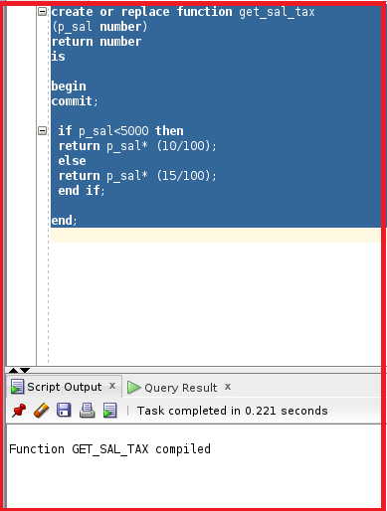
So, the function is now compiled. Let’s now try to run the select statement and see how the function works as we have added compile in the function.
Select employee_id, first_name, salary, get_sal_tax(salary) from employees where get_sal_tax(salary)>2000 and order by get_sal_tax(salary);

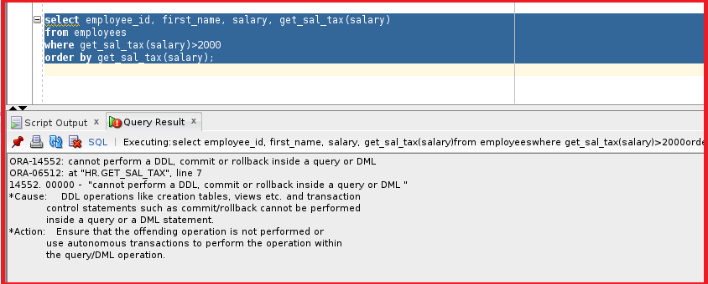
We can see the error mentioning” Cannot perform a DDL, commit or rollback inside a query or DML”. So, this means if the select statement is calling any function, then the PL/SQL block contained in the function should not contain commit or rollback. But without the select statement by declaring variable it works. Let’s take the below example.
declare
v number;
begin
v:=get_sal_tax(5000);
DBMS_OUTPUT.put_line(v);
end;
We have declared a variable ‘v’ with a number as a datatype. The return value is now assigned to v. Let’s try to execute this pl.sql block.
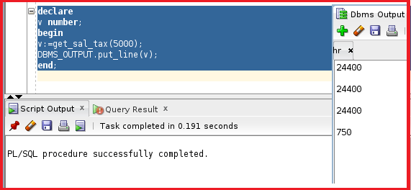
The PL/SQL block is executed and we can see the tax is 750 in DBMS OUTPUT. Let’s try another example. Let’s try to use the insert statement in the function and try to execute the function in the select statement or in the separate PL/SQL block.
create or replace function get_sal_tax
(p_sal number)
return number
is
begin
insert into DEPARTMENTS (DEPARTMENT_ID, DEPARTMENT_NAME)
values (-99,'test');
if p_sal<5000 then
return p_sal* (10/100);
else
return p_sal* (15/100);
end if;
end;
In the above function, we have added an insert statement that inserts records into the department table. Let’s try to compile this function.
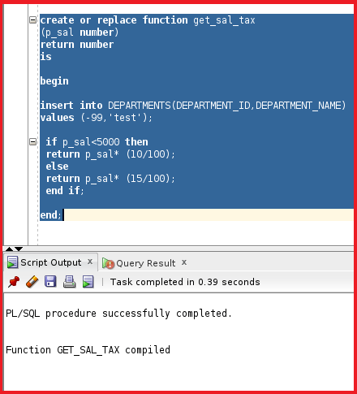
So, the function is now compiled. Let’s try to call this function in the select statement and see how this works.
select employee_id, first_name, salary, get_sal_tax(salary)
from employees
where get_sal_tax(salary)>2000
order by get_sal_tax(salary);
Let’s try to execute this select statement.
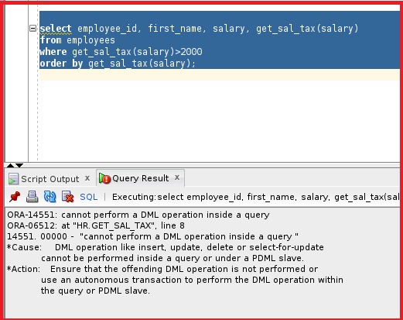
So, we are getting the same error which showing cannot perform a DML operation inside a query. But we can execute the function by declaring the variable and calling the function as below.
declare
v number;
begin
v:=get_sal_tax(5000);
DBMS_OUTPUT.put_line(v);
end;
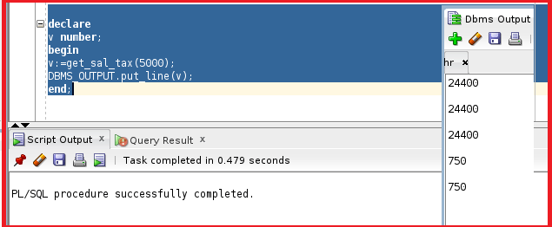
Let’s now check if the record is inserted in the departments table or not.
select * from departments where department_id=-99;
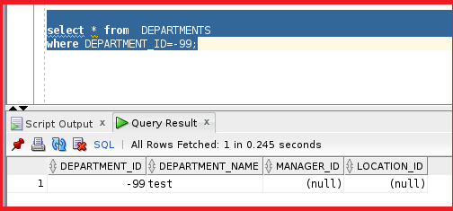
So, we can see the record as well in the departments table. We use the function to return a value. We don’t use the function to insert records. We can also drop the function in the below drop command.
drop function get_sal_tax;
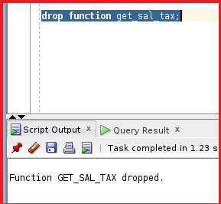
So, the function is now dropped. This is how we play with the functions. We have learned about how to create functions and how to use user-defined functions and restrictions with functions.

Function with default parameter value
CREATE OR REPLACE FUNCTION calc_net_salary
(
p_basic NUMBER,
p_hra_pct NUMBER DEFAULT 20,
p_tax_pct NUMBER DEFAULT 10
)
RETURN NUMBER
IS
v_hra NUMBER;
v_tax NUMBER;
BEGIN
v_hra := p_basic * (p_hra_pct / 100);
v_tax := p_basic * (p_tax_pct / 100);

RETURN (p_basic + v_hra) - v_tax;
END;
/

Call by skipping defaults using named notation
SELECT calc_net_salary(p_basic => 50000) AS net
FROM dual;

Override ONLY tax, keep default HRA
SELECT calc_net_salary(p_basic => 50000, p_tax_pct => 15) AS net
FROM dual;

Change order freely
SELECT calc_net_salary(p_tax_pct => 12, p_basic => 50000, p_hra_pct => 25) AS net
FROM dual;

